MySQL

MySQL most popular open-source DBMS

Mostly written in C++, 1248 contributors representing almost 1.5M lines of code

Well established, mature code base that took almost 700 years of effort

Client Server Model:
- Server - mysqld. (daemon)
C:\wamp\bin\mysql\mysql5.6.12\bin\mysqld.exe
- Client/s - Users manipulate the data via Client/s

MySQL uses standard ISO/ANSI SQL: 2011 (7th version of SQL)

Many different clients on a wide range of platforms :
- MySQL command line client
- phpMyAdmin
- MySQL Query Browser
- MySQL Administrator
- MySQL WorkBench
- Front end language, e,g, C, C++, C#, PHP, Java, etc
- ODBC / JDBC

My: co-founder Monty Widenius's daughter,

Sakila: Dolphin (logo) is named in a “Name the Dolphin” contest.

MySQL command line client

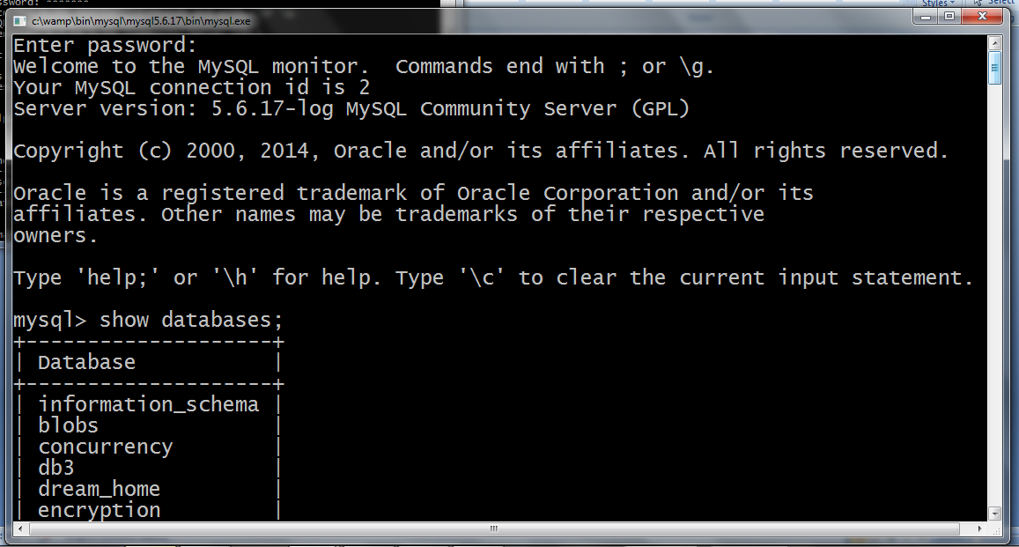

Huge amount of information on the web about MySQL

The most important is the reference manual:

http://dev.mysql.com/doc/refman/5.6/en/index.html

The manual is searchable, but Google usually gives better results (if you prefix your search phrase with MySQL).

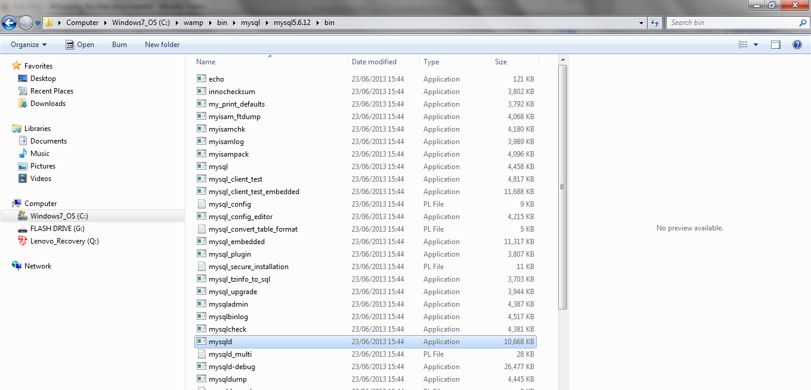

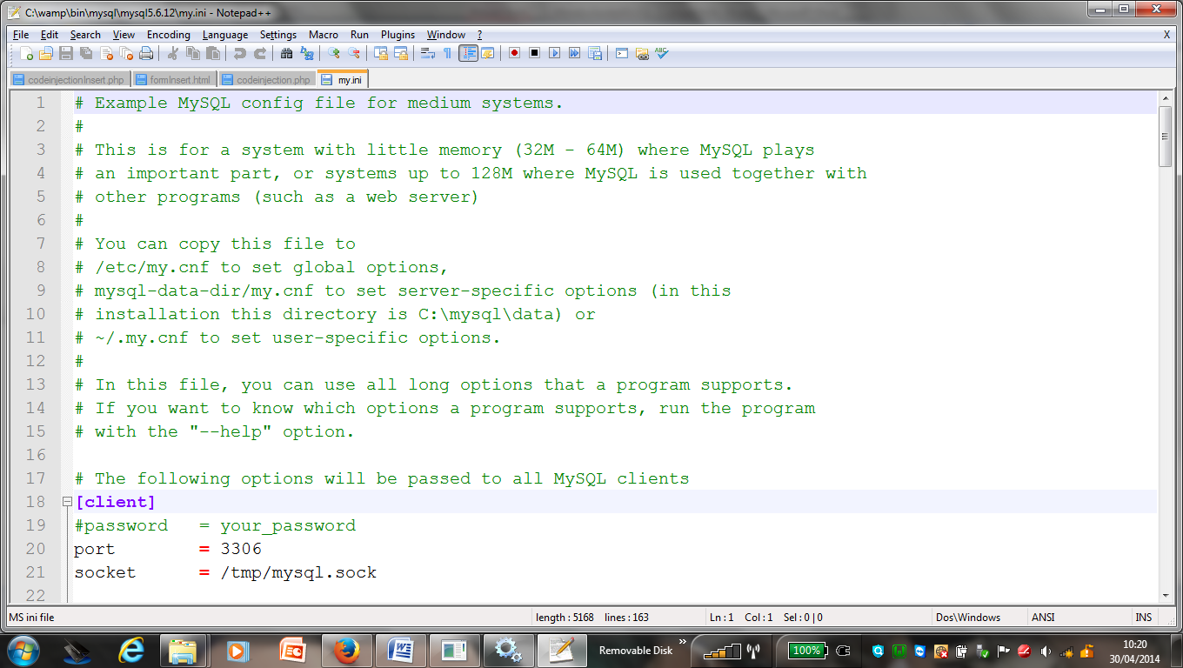

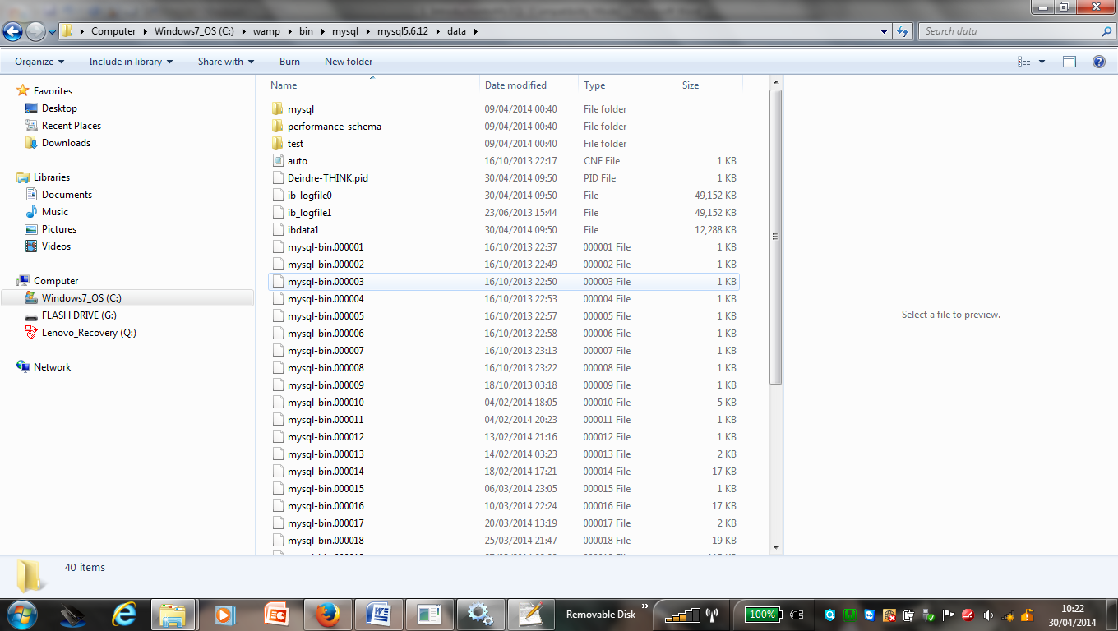

MySQL creates an .frm file to hold table and column definitions

The Innodb storage engine stores all the data from all tables in one file called ibdata1!, possible to have one file per table by setting the @@innodb_file_per_table global variable

MyISAM storage engine, has separate tbl_name.MYD and tbl_name.MYI files for indexes and data

Creating and Populating Tables

- Open mysql command line client window and type in each sql statement, one at a time.

- Open mysql command line client window and call a script file using SOURCE command

See below
source f:/createempdepttable.sql;

- Use WAMP / phpmyadmin to import *.sql file

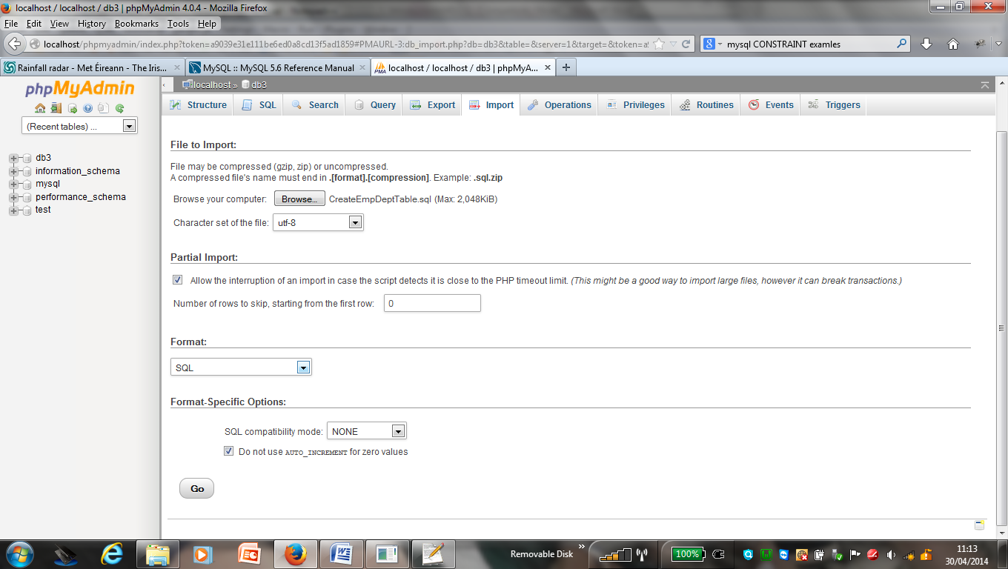

Quotes
Single or Double

There are two types of quotes in MySQL:
- ' for enclosing string literals
- ` for enclosing identifier, e.g. table, column
- " is a special case - depending on MySQL server's sql_mode:

Comment Syntax

- ‘#’ character to the end of the line.
- ‘-- ‘ sequence to the end of the line.
- /* */ inline or multiline

Section 13.1.17

CREATE [TEMPORARY] TABLE [IF NOT EXISTS] tbl_name

32 different data types each with various different options

MySQL displays DATE values in 'YYYY-MM-DD' format

20 different table options

Alter Table …….
Rename Table…..

If table is already created possible to load data into tables from tsv or csv file (tab separated values, comma separated values)

copy emp.tsv file to desktop

Notice the forward slash /

Load data local infile “G:/emp.tsv” into table emp
lines terminated by “\r\n”;

notice “ ” around file name in above statement!!

Alternate:

Load data local infile “c:/emp.csv” into table emp
Fields terminated by “,” Lines terminated by ‘\r\n’;

